Lab 3

- 8-Queens: All Solutions + Board Visualization
Write a Python program to solve the 8-Queens problem using backtracking and print all 92 solutions. Add a board visualization to your solution — print the
chessboard using Q for queens and . for empty cells.
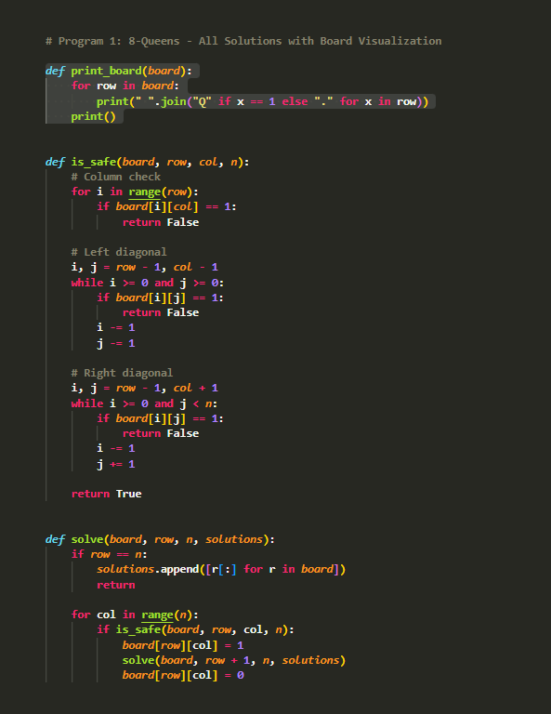

OUTPUT:
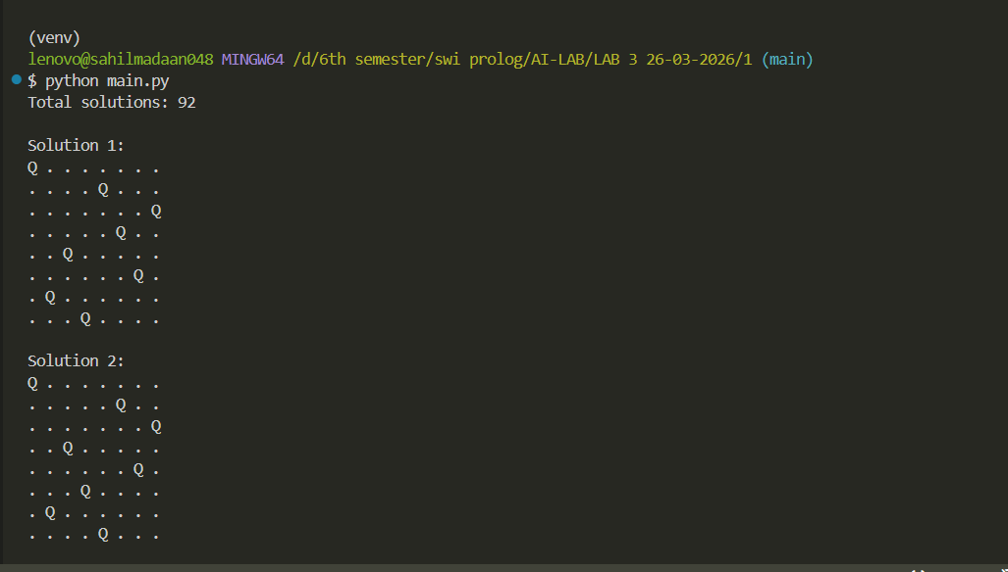

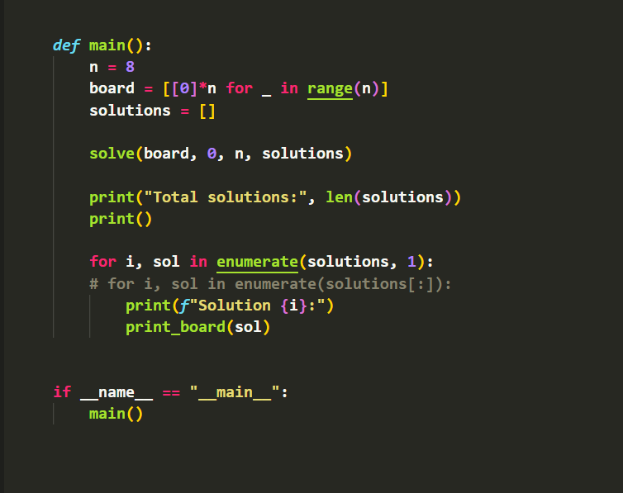

OUTPUT:
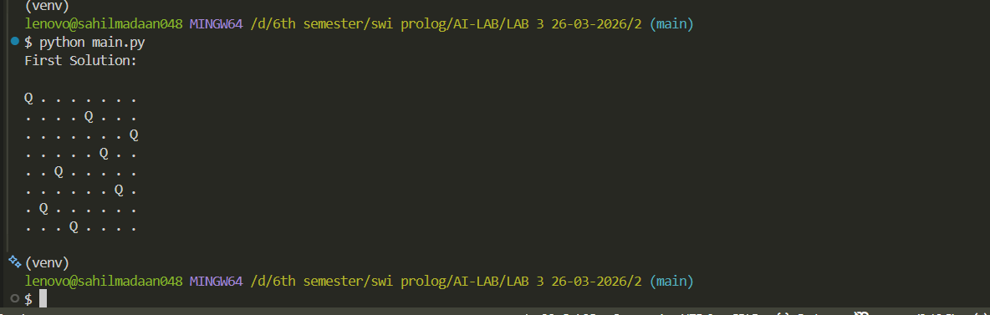

Lab 3

- 8-Queens: First Valid Solution
Write a Python program to solve the 8-Queens problem to print only the first valid solution found and terminate immediately

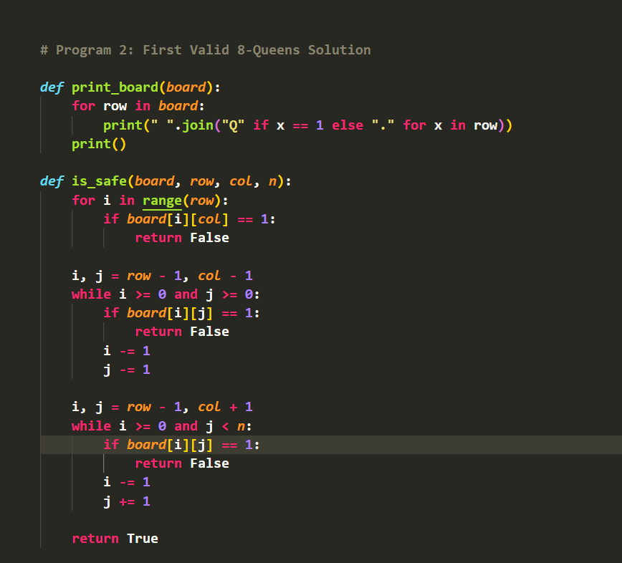

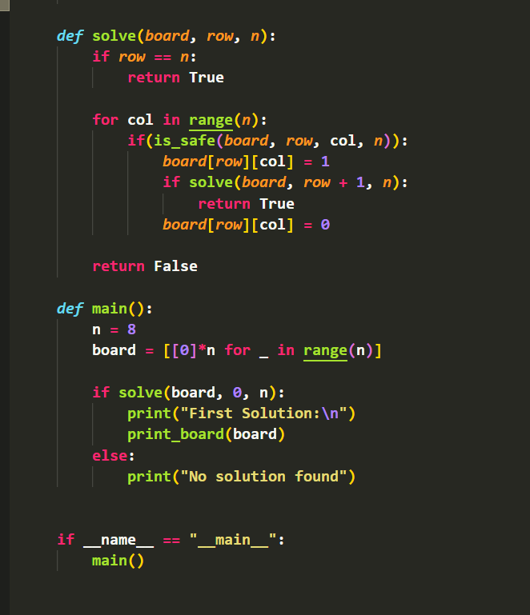

OUTPUT:
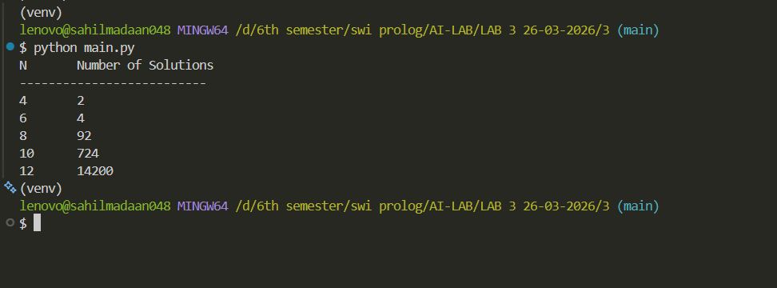

Lab 3
- Generalized N-Queens Problem
Generalize your solution to solve the N-Queens problem for any N given as input. Test it for N = 4, 6, 8, 10, and 12. Tabulate the number of solutions for each
value of N.
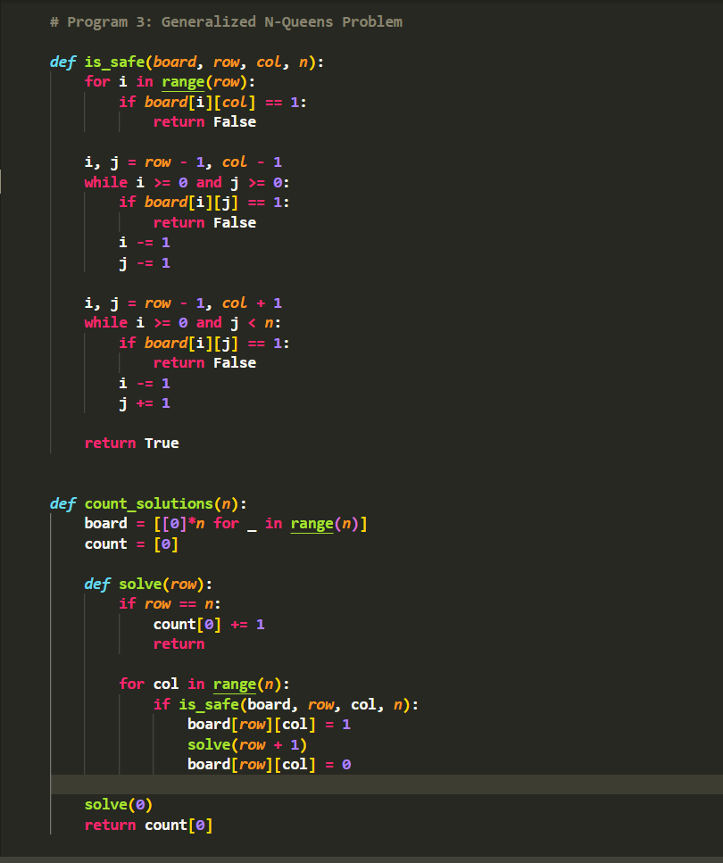

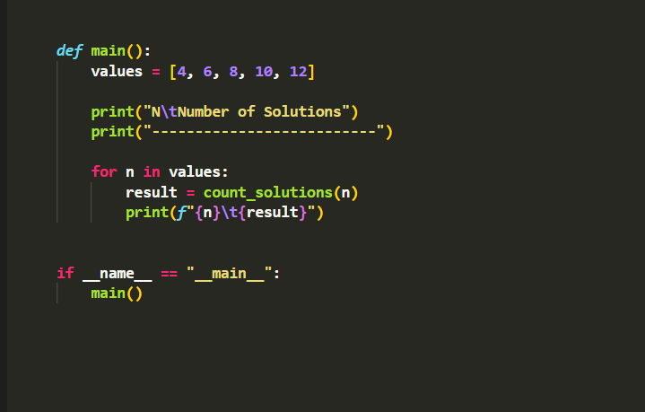

OUTPUT:
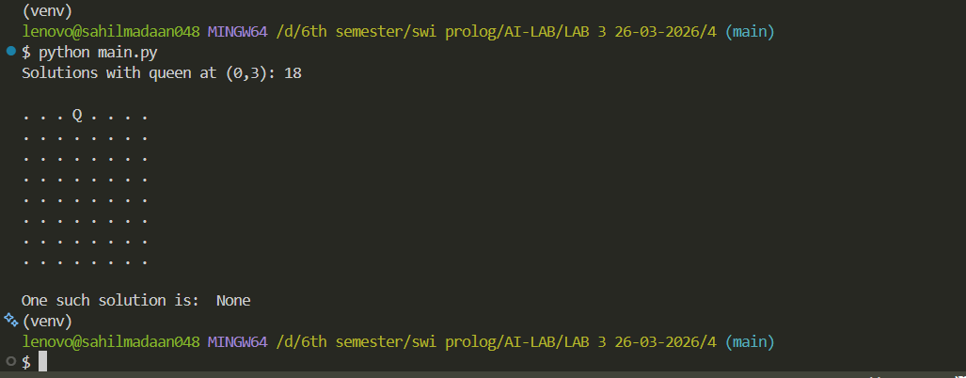

Lab 4
- Pre-Placed Queen Constraint
Modify the program so that one queen is pre-placed at position (0, 3) — row 0, column 3. How many valid solutions exist with this fixed constraint?
